 | 19.1.6 Editors - Drivers Editor - Key Menu
Table of content
Drivers Editor - Key Menu 3
Transform 3
Grab/Move 3
Last Operator Move 3
Move X, Y Z 3
Orientation 3
Proportional editing 3
Proportional Falloff 3
Proportional Size 4
Connected 4
Projected(2D) 4
Extend 4
Last Operator Transform 4
Values X, Y Z, W 4
Axis 4
Orientation 4
Proportional editing 4
Proportional Falloff 4
Proportional Size 4
Connected 4
Projected(2D) 4
Rotate 5
Last Operator Rotate 5
Angle 5
Axis 5
Orientation 5
Proportional editing 5
Proportional Falloff 5
Proportional Size 5
Connected 5
Projected(2D) 5
Scale 5
Last Operator Resize 6
Angle 6
Axis 6
Orientation 6
Proportional editing 6
Proportional Falloff 6
Proportional Size 6
Connected 6
Projected(2D) 6
Snap 6
Last Operator Snap Keys 6
Type 6
Mirror 7
Last Operator Mirror Keys 7
Type 7
Insert Keyframes 7
Last Operator Insert Keyframes 7
Type 7
Jump to Keyframes 7
Copy Keyframes 7
Paste Keyframes 7
Paste Flipped 7
Last Operator Paste Keyframes / Flipped 7
Offset 7
Type 7
Flipped 8
Duplicate 8
Last Operator Duplicate 8
Mode 8
Values X / Y 8
Axis 8
Orientation 8
Proportional editing 8
Proportional Falloff 8
Proportional Size 8
Connected 8
Projected(2D) 8
Delete Keyframes 8
Decimate (Ratio) 9
Decimate (Allowed Change) 9
Last Operator Decimate Keyframes 9
Mode 9
Remove or Max Error Margin 9
Clean Keyframes 9
Clean Channels 9
Last Operator Clean Keyframes 9
Threshold 9
Channels 9
Smooth Keys 9
Keys to Samples 9
Sample to Keys 9
Sound to Samples 10
Bake Channels 10

Drivers Editor - Key Menu
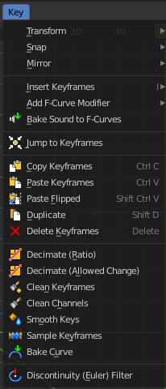
This menu contains functionality to manage the keyframes.

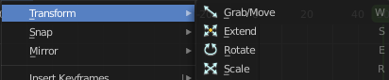
Transform

Grab/Move
Moves the selected keyframe(s).

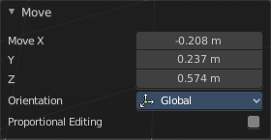
Last Operator Move

Move X, Y Z
The position. Attention, the actual world orientation and rotation does not matter here. It always starts with a value of zero, and moves relative to this zero then. For the actual location values have a look in the sidebar in the transform panel.

Orientation

The widget can have different orientations. The menu items should be self explaining.

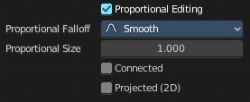
Proportional editing
Enables proportional editing. Activating proportional editing reveals further settings.

Proportional Falloff
Adjust the falloff methods.

Proportional Size
See and adjust the falloff radius.

Connected
The proportional falloff gets calculated for connected parts only.

Projected(2D)
The proportional falloff gets calculated in the screen space. Depth doesn't play a role. When it's in the radius, then it gets calculated.

Extend
Moves the last keyframes of the selection.

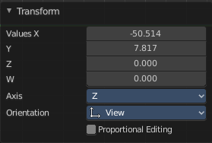
Last Operator Transform

Values X, Y Z, W
The new position.

Axis
Which axis to transform.

Orientation
The widget can have different orientations. The menu items should be self explaining.

Proportional editing
Enables proportional editing. Activating proportional editing reveals further settings.

Proportional Falloff
Adjust the falloff methods.

Proportional Size
See and adjust the falloff radius.

Connected
The proportional falloff gets calculated for connected parts only.

Projected(2D)
The proportional falloff gets calculated in the screen space. Depth doesn't play a role. When it's in the radius, then it gets calculated.

Rotate
Rotates the selection.

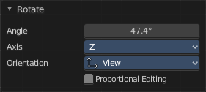
Last Operator Rotate

Angle
The rotation. Attention, the actual world orientation and rotation does not matter here. It always starts with a value of zero, and rotates relative to this zero then. For the actual rotation values have a look in the sidebar in the transform panel.

Axis
Which axis to rotate.

Orientation
The widget can have different orientations. The menu items should be self explaining.

Proportional editing
Enables proportional editing. Activating proportional editing reveals further settings.

Proportional Falloff
Adjust the falloff methods.

Proportional Size
See and adjust the falloff radius.

Connected
The proportional falloff gets calculated for connected parts only.

Projected(2D)
The proportional falloff gets calculated in the screen space. Depth doesn't play a role. When it's in the radius, then it gets calculated.

Scale
Scales the selected keyframes. You need to have more than one keyframe selected.

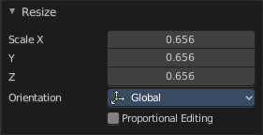
Last Operator Resize

Angle
The rotation. Attention, the actual world orientation and rotation does not matter here. It always starts with a value of zero, and rotates relative to this zero then. For the actual rotation values have a look in the sidebar in the transform panel.

Axis
Which axis to rotate.

Orientation
The widget can have different orientations. The menu items should be self explaining.

Proportional editing
Enables proportional editing. Activating proportional editing reveals further settings.

Proportional Falloff
Adjust the falloff methods.

Proportional Size
See and adjust the falloff radius.

Connected
The proportional falloff gets calculated for connected parts only.

Projected(2D)
The proportional falloff gets calculated in the screen space. Depth doesn't play a role. When it's in the radius, then it gets calculated.

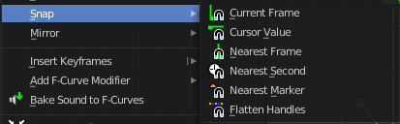
Snap
Snaps the selected keyframes by the chosen method.

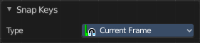
Last Operator Snap Keys

Type
Snaps the selected keyframes by the chosen method.

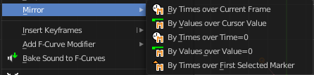
Mirror
Flips the selected keyframes over the current frame position.

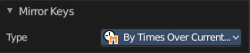
Last Operator Mirror Keys

Type
Flips the selected keyframes over the current frame position by the chosen method.

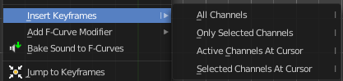
Insert Keyframes
Choose a method how to insert a new keyframe at the current frame position.

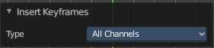
Last Operator Insert Keyframes

Type
Choose a method how to insert a new keyframe at the current frame position.

Jump to Keyframes
Sets the frame marker at the average position of the currently selected keyframes.

Copy Keyframes
Copy selected keyframes.

Paste Keyframes
Pastes copied keyframes.

Paste Flipped
Pastes copied keyframes, but flipped.

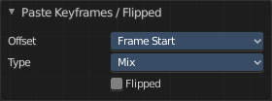
Last Operator Paste Keyframes / Flipped

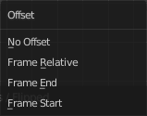
Offset
Define an offset for the paste position.

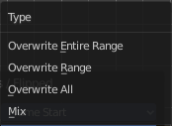
Type
Choose a method how to paste the copied keyframes.

Flipped
Pastes keyframes from mirrored bones if they exists.

Duplicate
Duplicate selected keyframes.

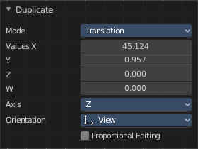
Last Operator Duplicate

Mode

Values X / Y
The x and y values for the pasted keyframes. Note that these values starts at the position of the original copied keyframe. These values are relative.
Values Z and W have no effect here.

Axis
These values have no effect.

Orientation
These values have no effect.

Proportional editing
Enables proportional editing. Activating proportional editing reveals further settings.

Proportional Falloff
Adjust the falloff methods.

Proportional Size
See and adjust the falloff radius.

Connected
The proportional falloff gets calculated for connected parts only.

Projected(2D)
The proportional falloff gets calculated in the screen space. Depth doesn't play a role. When it's in the radius, then it gets calculated.

Delete Keyframes
Deletes selected keyframes.

Decimate (Ratio)
Decimate F-Curves by removing keyframes that that has the least influence to the curve shape.

Decimate (Allowed Change)
Decimate F-Curves by specifying how much it can derivate from the original curve.

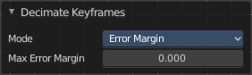
Last Operator Decimate Keyframes

Mode
The decimate mode. Error margin is Allowed change.

Remove or Max Error Margin
The percentage of keyframes to remove.

Clean Keyframes
Simplify FCurces by deleting keyframes that are close to each other in all channels.

Clean Channels
Simplify FCurces by deleting keyframes that are close to each other in selected channels.

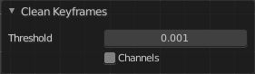
Last Operator Clean Keyframes

Threshold
The threshold amount for the simplify algorithm.

Channels
Clean keyframes or channels.

Smooth Keys
Make selected curves less bumpy.

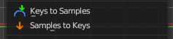
Keys to Samples
Bake selected F-Curves to a set of sampled points. This makes the curve not longer editable.

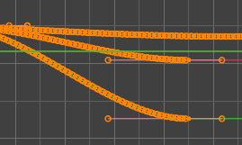
Sample to Keys
Un-bake a sampled point F-Curve to make it editable again.

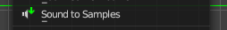
Sound to Samples
This operator takes a sound file and uses its sound wave to create the animation data. When running it, you will be prompted to load an audio file to apply to the selected channels.

Bake Channels
Creates keyframes following the current shape of F-Curves of selected channels for the entire channel within the frame range.

